Insertion Electromagnetic Flowmeter (IEF) firmware update guide

The purpose of this document is to describe the procedure required to update firmware on the IEF mainboard and display.

Requirements

The following items are required to perform a firmware update on the display.
- PC with Windows XP or newer
- Mini-USB cable
- IEF display to be updated
- SAM-BA v2.18 or higher firmware update application
- Firmware file: MagFlowDisplay_X_X_XXX.bin

Setup

- Install SAM-BA firmware updater application by double clicking sam-ba_2.16.exe and follow the prompts.

Update Display Firmware Procedure

- Disconnect the ribbon cable and USB cable if connected.
- Plug the USB cable into the PC.
- Press and hold the RIGHT and MENU buttons.
- With the buttons held, plug the mini-USB cable into the display. The buttons can be released after the Windows USB enumeration sound is heard. If successful, the backlight will be on, but no image will be display on the LCD. The display is now in firmware update mode.
- Start the SAM-BA application.
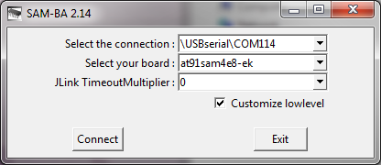
- In the dialog, verify the “Select the connection” value is “\USBserial\COMxx”. Where XX is the virtual COM port assign to the IEF mainboard.
- Select “at91sam4e8-ek” from the “Select you board” selection box.
- Check the box next to “Customize lowlevel” and click the “Connect” button.
- Select “16000000” from the “Select on board crystal” selection box and click the “Set” button.
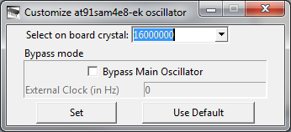
- In the “Download/Upload File” section, select the folder icon next to the “Send File” button.
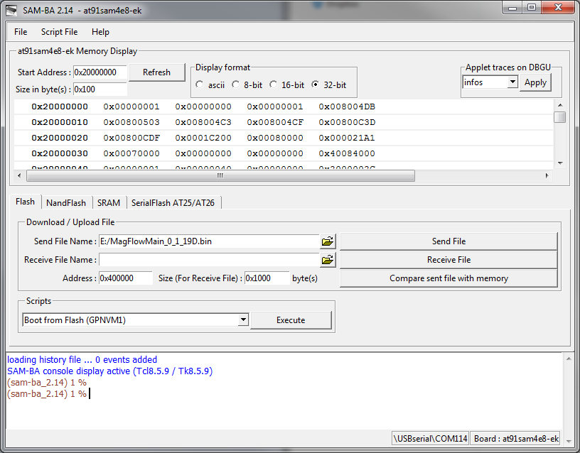
- Navigate to and select the new firmware file. Click the “Send File” button to start the download.
- The download process should only take a few seconds.
- A dialog prompt will ask if you want to lock regions. Click the “No” button.
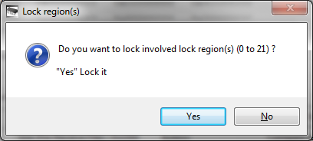

- In the “Scripts” section, select “Boot from Flash (GPNVM1)” from the selection box and click “Execute”.
- Close the SAM-BA application.
- Unplug the USB cable from the display.
- To verify the display firmware version, connect the ribbon cable from the display to a powered mainboard. If the display is running demo firmware, just plug in the mini-USB cable.
- Ensure the firmware version (FV) under “Display” matches the desired version.

